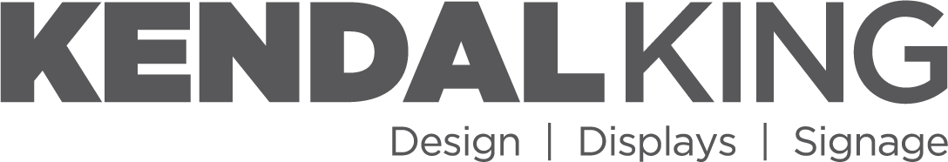  609 SW 8th St • Ste 140 • Bentonville, AR 72712 |  |  |  |  |  |  |  |  | UNIFORM BILL OF LADING
 |  |  |  |  |  |  |  | BOL # | MBOL-001
 |  |  |  |  |  |  |  | Ship Date | 05/13/2026
 |  |  |  |  |  |  |  | Carrier | Test Carrier
 |  |  |  |  |  |  |  | Carrier Pro #
 |  |  |  |  |  |  |  | PO # | PO-0551
FROM (SHIPPER) |  |  |  |  |  |  |  | KK PO # | KKPO-001
COMPANY | Kendal King C/O Productiv |  |  |  |  |  |  | KK Load # | 1
 |  |  |  |  |  |  |  | Seal #
STREET | 4255 Patriot Drive Suite 400  Grapevine, TX |  |  |  |  |  |  | Pick Up # | Comments: Keep dry
ATTN
TO (CONSIGNEE) |  |  |  |  |  |  |  | FREIGHT CHARGE TERMS:
COMPANY | DC 0551 |  |  |  |  |  |  |  | X FREIGHT PREPAID
 |  |  |  |  |  |  |  |  | FREIGHT COLLECT
STREET | 1 Stop Way |  |  |  |  |  |  |  | FREIGHT THIRD PARTY
CITY/ST/ZIP | Dallas, TX 75001 |  |  |  |  |  |  | BILL TO:
Acme Freight
505 Riverfront Pkwy
DC# |  |  |  |  |  |  |  | Chattanooga, TN 37402
 | SUBJECT TO SECTION 7: Of the conditions if shipment is to be delivered to consignee without recourse on the consignor, the consignor shall sign the following statement: The Carrier shall not make delivery of the shipment without payment of the freight and all other lawful charges.
 |  |  |  |  |  |  |  | Attn:
The transportation of the property described herein is tendered and accepted subject to applicable federal transportation law and the written agreements between the Parties. In the event of any conflict between this Bill of Lading and any other document, the applicable written contract between Kendal King Group and the Broker of Record shall control. Nothing herein shall be construed to impose payment responsibility on Kendal King Group beyond its obligation to pay the Broker of Record in accordance with the governing agreement.

Pallet Qty | Type |  | PO # |  | ITEM DESCRIPTION |  |  |  |  |  | # SKIDS |  |  | WEIGHT
10 | PLT |  | PO-0551 |  | Stop one pallet  Item #: ITEM1 UPC #: 000111222333 |  |  |  |  |  | 2 |  |  | 100
10 |  |  |  |  | TOTALS |  |  |  |  |  | 2 |  |  | 100
Shipper Signature:

CUSTOMER NOTE: Please check this shipment carefully. No returns accepted without prior approval. If shipment does not agree with this manifest, have carrier note discrepancy on receipt and notify shipper immediately.

Receiver Signature:
Driver Signature:

BROKER PAYMENT & NO RECOURSE NOTICE
Broker of Record: ACME FREIGHT
Freight charges for this shipment are to be paid solely by the Broker of Record. Carrier agrees that it shall look exclusively to the Broker for payment of freight charges and hereby waives any right of recourse against Kendal King Group for unpaid freight charges. Payment by Kendal King Group to Broker shall constitute full satisfaction of Shipper’s freight payment obligation. Carrier acknowledges and agrees that it has no lien, claim, or right to pursue Kendal King Group for unpaid freight charges. This provision shall survive delivery and any termination of transportation services.

